PROJECT REPORT:
Air Quality Index (AQI) Forecasting System

Project Introduction

Product Description / Objectives
This project builds a backend pipeline for forecasting the Air Quality Index (AQI) in Hanoi for the next 6 hours (t+6), utilizing multiple model architectures: LSTM, Stacked LSTM, GRU, and XGBoost (with Lag Features) on the PyTorch platform. The pipeline takes a 48-hour historical sliding window of data from environmental and air quality IoT sensors as input, and outputs the forecasted AQI value for the next 6 hours.
Specific Objectives:
- Build a time-series data processing system that preserves temporal continuity.
- Train and compare multiple model architectures (LSTM, Stacked LSTM, GRU, XGBoost).
- Optimize hyperparameters automatically using Optuna (Bayesian HPO).

Project Requirements
 | Requirement | Description
1 | Real-world IoT data | Use time-series dataset of Hanoi’s air quality (08/2022 – 06/2025, 30,335 rows × 21 columns), including AQI, PM2.5, PM10, CO, NO₂, O₃, SO₂, temperature, humidity, wind speed, pressure.
2 | Standard data preprocessing | Handle outliers without breaking the timeline; scale data without causing data leakage; split data chronologically.
3 | Diverse models | Design and evaluate multiple architectures: Base LSTM (1-layer), Stacked LSTM (2-layer), Single-layer GRU, and XGBoost (with Lag Features).
4 | Hyperparameter tuning | Integrate Bayesian Optimization (Optuna) to automatically find the optimal hyperparameter combination.
5 | Objective evaluation | Compare model results with a Naive Persistence Baseline to prove the models actually learn patterns.
6 | Modular architecture | Separate source code into distinct modules (config, data, model, train, evaluate, visualize, utils).
 | Logging & reproducibility | Log results and ensure reproducibility using fixed seeds.

Implementation Methodology

Functional Analysis & System Design

Module Descriptions
Module | File | Function
Configuration | src/config.py | Defines all hyperparameters, feature columns, data split ratios, device, and random seed.
Data Processing | src/data_loader.py | Reads CSV, handles outliers (AQI > 400 → NaN), extracts time features (hour, month), interpolates, performs chronological split, scales using MinMaxScaler, creates sliding-window sequences, and creates PyTorch DataLoaders. Also supports get_xgboost_data() to return flattened arrays for XGBoost.
Models | src/model.py | Defines LSTMAQIModel (1-layer LSTM), StackedLSTMAQIModel (2-layer LSTM), GRUAQIModel (1-layer GRU): all following the RNN + Dropout + Linear(hidden→1) structure.
Training | src/train.py | Training loop with early stopping, checkpointing, and trial pruning support for Optuna.
HPO Tuning | src/tune.py | Objective functions for Optuna – samples lr, hidden_size, dropout, weight_decay; trains and returns best val loss.
Evaluation | src/evaluate.py | Calculates RMSE, MAE on unscaled data; calculates Naive Persistence Baseline.
Visualization | src/visualize.py | Plots loss curves and actual vs. predicted AQI charts.
Utilities | src/utils.py | DualLogger – a context manager that logs output to both console and file simultaneously, ensuring exception safety.

Installation & Execution Guide
- System Requirements & Tool Versions
Tool | Version
Python | 3.10+
PyTorch | >= 2.0
scikit-learn | >= 1.0
Optuna | >= 3.0
Pandas | >= 1.5
NumPy | >= 1.23
Matplotlib | >= 3.6
XGBoost | >= 3.0

- Installation Steps
# 1. Clone repository
git clone <repository-url>
cd GR1
# 2. Create virtual environment
python -m venv .venv
# 3. Activate virtual environment
# Windows:
.venv\Scripts\activate
# Linux/macOS:
source .venv/bin/activate
# 4. Install dependencies
pip install -r requirements.txt
- How to Run
# Train Base LSTM model
python "main program/main.py"

# Train Stacked LSTM model
python "main program/stacked_main.py"

# Train and evaluate Single-layer GRU
python "main program/run_gru.py"

# Train and evaluate XGBoost (Lag Features, default params)
python "main program/run_xgb.py"

# HPO + retrain: Tuned Base LSTM
python "main program/tune_main.py"

# HPO + retrain: Tuned Stacked LSTM
python "main program/tune_stacked_main.py"

# HPO + retrain: Tuned GRU
python "main program/tune_gru_main.py"

# HPO + retrain: Tuned XGBoost
python "main program/tune_xgb_main.py"

# Generate overlay comparison charts
python compare_tuned_models.py
python compare_tuned_vs_untuned.py
- Differences from Original Notebook
The project was developed from an initial research notebook (Copy of Air Quality ForeCasting.ipynb) and addresses 6 main issues:
Issue | Original Notebook | New Pipeline
Structure | Monolithic Jupyter notebook | Modular Python package (src/)
Outlier Handling | Deleted rows with AQI > 400 broke timeline | Assigned NaN + time-interpolation preserved timeline
Data Leakage | Fit scaler on entire dataset | Fit scaler only on train set
Split Ratio | 70/10/20 but deleted AQI > 400 rows fewer samples | 70/10/20, interpolated AQI > 400 preserved timeline
Hyperparameters | Hardcoded | Automated Bayesian HPO (Optuna, 20 trials)
Baseline | None | Naive Persistence Baseline to prove actual learning
Architecture | 1 single-layer LSTM model | Base LSTM, Stacked LSTM, Tuned variants, GRU, XGBoost

Results

Training & Validation Performance
Model / Run | Train Scaled MSE | Train Unscaled RMSE | Train Unscaled MAE | Val Scaled MSE | Val Unscaled RMSE | Val Unscaled MAE
Notebook LSTM (original) | 0.0075 | 34.1876 | 26.1085 | 0.0058 | 29.9248 | 21.5537
Base LSTM | 0.0084 | 36.1757 | 28.0591 | 0.0058 | 30.1247 | 22.2817
Stacked LSTM | 0.0070 | 32.9880 | 25.1890 | 0.0058 | 29.9727 | 21.6667
Tuned Base LSTM | 0.0069 | 32.7617 | 25.1370 | 0.0056 | 29.4381 | 21.6108
Tuned Stacked LSTM | 0.0071 | 33.2378 | 25.0520 | 0.0055 | 29.2181 | 20.9574
Single-layer GRU | 0.0079 | 35.1279 | 27.4554 | 0.0058 | 29.9219 | 22.5277
Tuned Single-layer GRU | 0.0069 | 32.8135 | 25.2708 | 0.0056 | 29.3865 | 21.7875
XGBoost (Lag Features) | 0.0038 | 24.2739 | 18.6621 | 0.0057 | 29.6919 | 22.5971
Tuned XGBoost | 0.0047 | 27.0203 | 20.7062 | 0.0057 | 29.7005 | 22.8860

Notebook LSTM (original): Used 70/10/20 split but deleted rows where AQI > 400 (no interpolation), breaking the timeline. The model trained on 21,097 (Train), 2,968 (Val), and 5,991 (Test) sequences. The scaler was fit on the entire dataset → caused data leakage.
Remarks:
- Val loss below train loss: For every LSTM/GRU variant, validation MSE/RMSE is consistently lower than training MSE/RMSE.
This is plausible given dropout (0.2-0.386) is active during training and disabled during evaluation, and/or the validation window may simply contain fewer extreme pollution spikes than the training window.
However, this pattern could equally reflect the validation segment being an inherently "easier" slice of the chronological timeline.
- HPO delivers modest, consistent gains for RNNs: Tuning improved val RMSE for all three recurrent architectures
- Base LSTM (30.12 29.44)
- Stacked LSTM (29.97 29.22)
- GRU (29.92 29.39).
These are real but small improvements (0.5-0.75 RMSE points), not transformative ones.
- XGBoost fits training data far better than any neural model (train RMSE 24.27 vs. ~33-36 for LSTM/GRU variants), but its validation RMSE (29.69) is not better than the tuned RNNs.
This is the classic signature of a model with lower bias and higher variance on this feature representation: 624 flattened lag features let XGBoost fit the training set very tightly, but that tighter fit is not translating into a validation advantage.
- Hyperparameter tuning made XGBoost less overfit.
Untuned XGBoost achieves train RMSE 24.27 and val RMSE 29.69, a train/val gap of 5.42 points, the largest of any model in this study. After tuning, train RMSE rises to 27.02 and val RMSE is essentially flat at 29.70, narrowing the gap to 2.68 points.
However, this narrower train/val gap suggests that tuning does help in reducing overfitting on training set, without costing anything on validation, which in turns helps improve performance on test set

Test Set Performance & Baseline Comparison
Model / Baseline | Test Scaled MSE | Test Unscaled RMSE | Test Unscaled MAE
Naive Baseline (Persistence) |  | 49.1951 | 36.8173
Notebook LSTM (original) | 0.0106 | 40.6027 | 31.6603
Base LSTM | 0.0110 | 41.2524 | 32.3012
Stacked LSTM | 0.0109 | 41.0533 | 31.7970
Tuned Base LSTM | 0.0108 | 40.9869 | 31.7906
Tuned Stacked LSTM | 0.0108 | 40.8716 | 31.5892
Single-layer GRU | 0.0107 | 40.6944 | 31.9603
Tuned Single-layer GRU | 0.0105 | 40.4583 | 31.3893
XGBoost (Lag Features) | 0.0102 | 39.8709 | 30.4246
Tuned XGBoost | 0.0101 | 39.6817 | 30.2843

Remarks:
- All models clearly beat the naive baseline. Naive Persistence (predicting t+6 equal to t) gives RMSE 49.20. Every trained model (deep learning or gradient boosting) beats it by 8 to 10 RMSE points.
This shows that models are learning genuine structure in the weather/pollution signal, not just relying on autocorrelation the way the naive baseline does.
- The gap between models on test set is still narrow, but wider than on validation set. Test RMSE ranges from 39.68 (Tuned XGBoost) to 41.25 (Base LSTM), about 1.6 points, compared to a 0.9 point spread on validation
- XGBoost tuning helped on test, unlike on validation.
Tuned XGBoost (39.68) outperforms untuned XGBoost (39.87) by about 0.19 RMSE points. This is consistent with the train/val gap analysis in Section 3.2: tuning narrowed XGBoost's train/val gap from 5.42 to 2.68 points, meaning the model became less overfit even though validation loss didn't visibly reflect it. The test set is what confirms this reduced overfitting actually translated into a real, if modest, generalization benefit.

Hyperparameter Analysis
Neural Network Models (LSTM / GRU)
Parameter | Base LSTM | Tuned Base LSTM | Tuned Stacked LSTM | Tuned GRU
Learning Rate | 5e-4 | 5.315e-4 | 7.385e-4 | 8.510e-4
Hidden Size | 128 | 128 | 256 | 256
Num layers | 1 | 1 | 2 | 1
Dropout | 0.2 | 0.2574 | 0.3496 | 0.3596
Weight Decay | 0.0 | 1.226e-5 | 3.047e-5 | 6.782e-6

XGBoost Model
Parameter | XGBoost (Default) | Tuned XGBoost (Best)
booster | gbtree | gbtree
eta (learning rate) | 0.05 | 0.0349
max_depth | 6 | 5
min_child_weight | 1 (default) | 7
subsample | 0.8 (default) | 0.900
colsample_bytree | 0.8 (default) | 0.385
Lambda/ alpha/gamma | 1.0/0.0/0.0 (default) | 2.912e-7 / 1.401e-5 / 7.234e-7
Grow_policy | Depthwise (default) | Depthwise
Num_boost_round | 200 (early stop at 117) | 200

Loss curves
- Base LSTM:
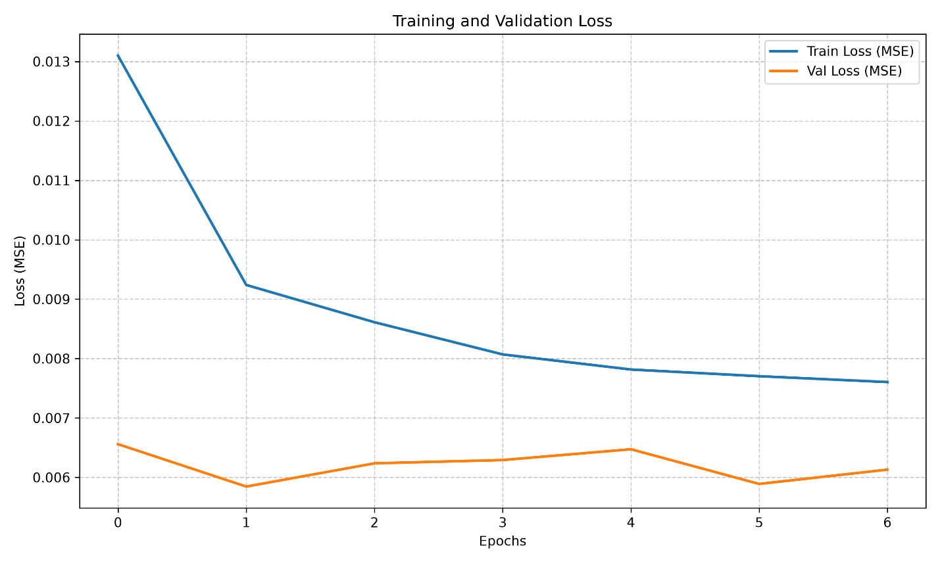
- Stacked LSTM:
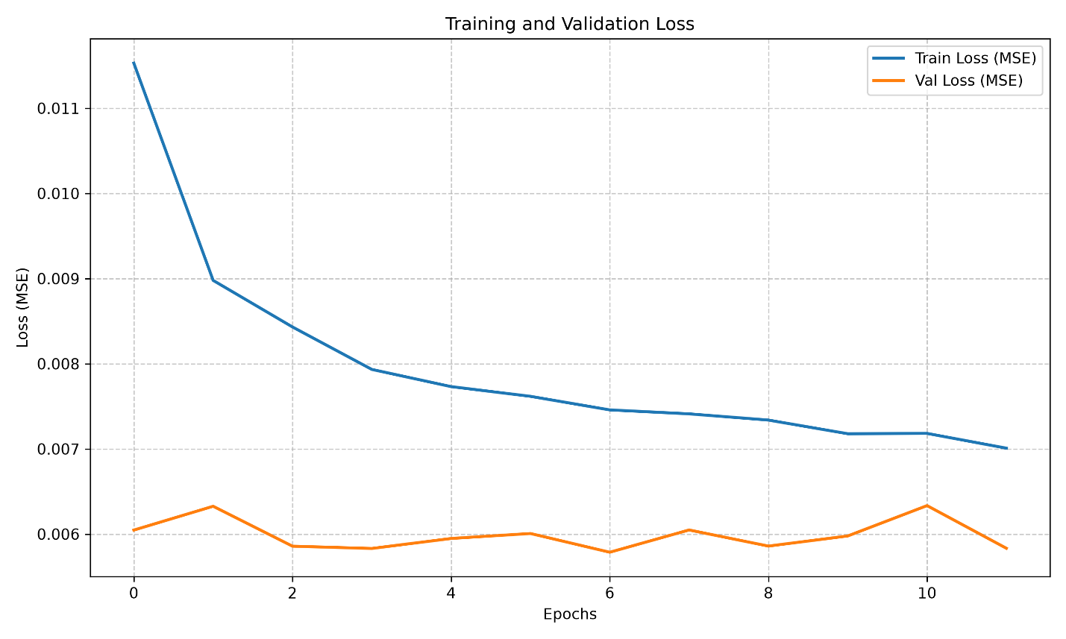
- Tuned Base LSTM:
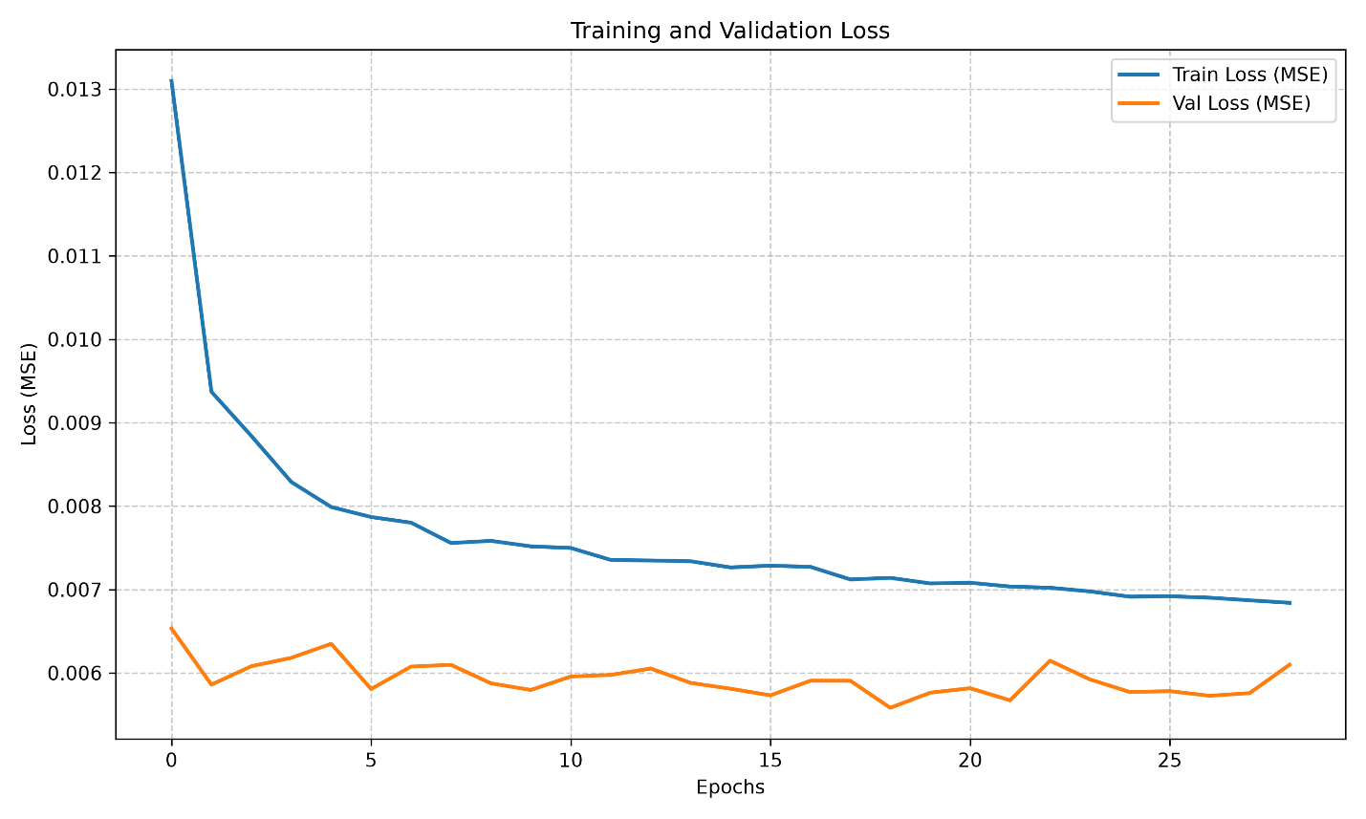
- Tuned Stacked LSTM:
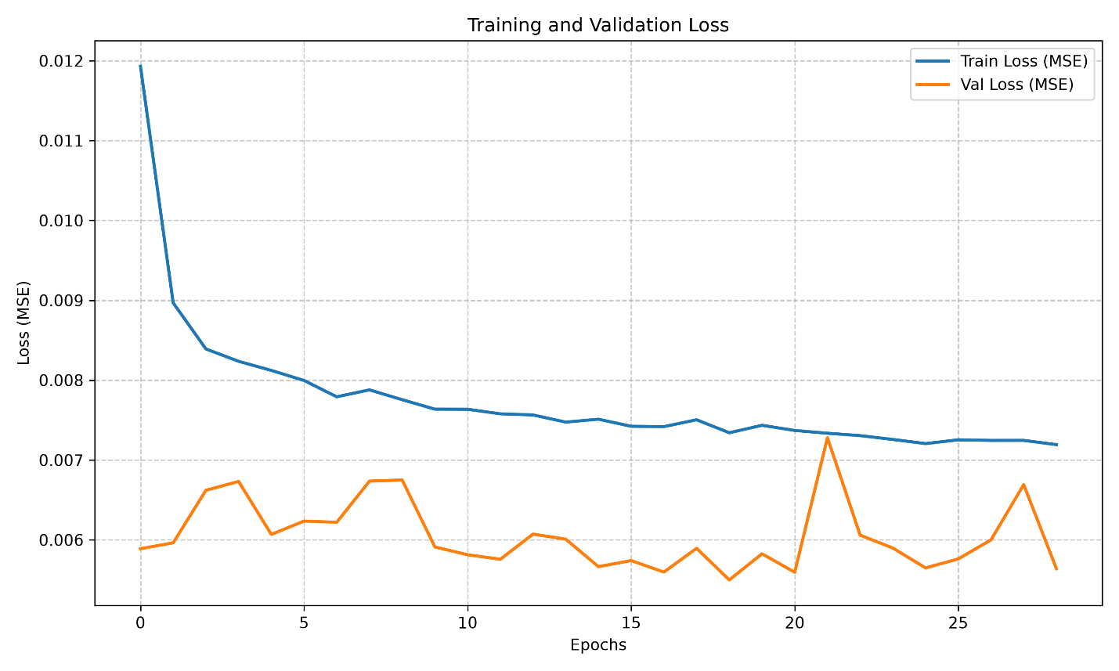
- Single-layer GRU:
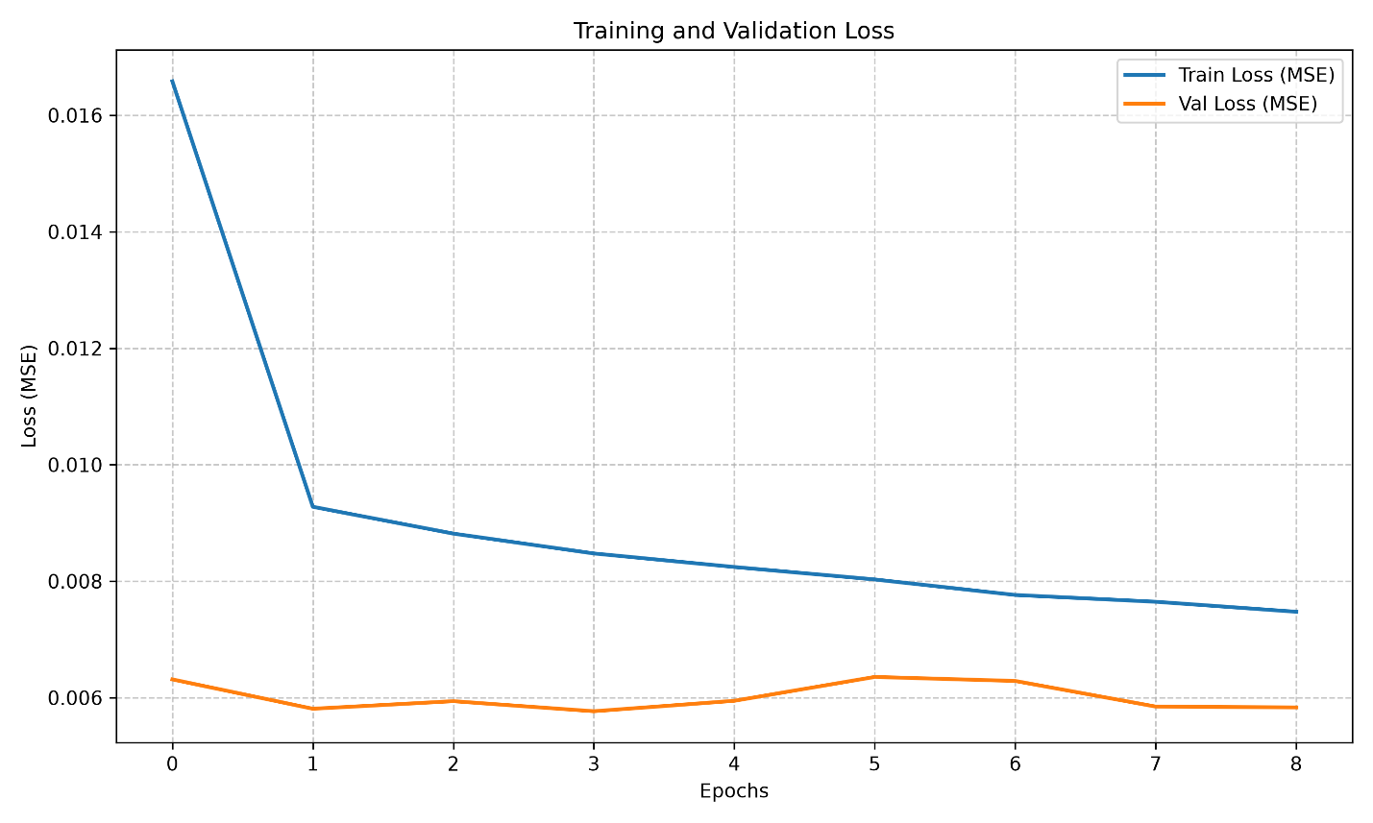
- Tuned GRU:
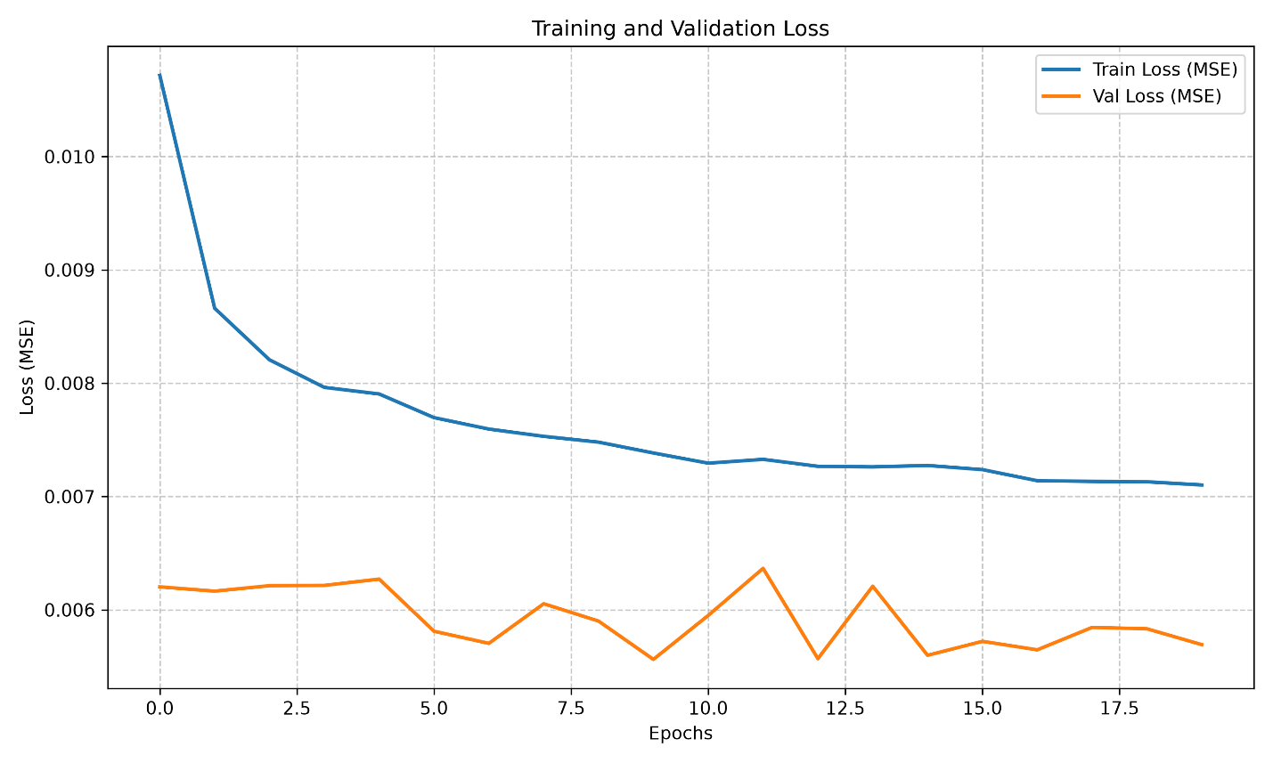
Overall Analysis:
- Consistent Patterns Across All Models
- The training loss decreased smoothly and monotonically without any signs of optimization instability (e.g., NaN values or oscillatory divergence), indicating that the selected learning rates and network architectures were appropriate for all experiments.
- The validation loss remained consistently lower than the training loss throughout training for every model. This behavior is a direct consequence of the use of dropout, which is enabled during training but disabled during evaluation.
- None of the models exhibited the classic symptoms of overfitting, where the validation loss begins to increase while the training loss continues to decrease. In all experiments, the early stopping mechanism terminated training at an appropriate point, preventing excessive fitting to the training data.
- A Clear Trend: Increased Model Complexity and Hyperparameter Tuning Lead to Higher Validation Loss Fluctuations
The most significant finding observed consistently across all experiments is that as the model becomes more complex or undergoes more aggressive hyperparameter tuning, the validation loss becomes increasingly noisy.
- Base LSTM and GRU (without hyperparameter tuning) exhibited relatively smooth validation loss curves with only minor fluctuations.
- Stacked LSTM (with additional LSTM layers but without tuning) showed noticeably greater fluctuations, with repeated peaks and valleys throughout training.
- Tuned GRU and Tuned Stacked LSTM (optimized using Optuna with higher dropout rates and more aggressive learning rates) produced the most unstable validation loss curves, including several sharp spikes—particularly the Tuned Stacked LSTM around epoch 21.
- Tuned Base LSTM represents a partial exception. Although it was also optimized using Optuna, its validation loss remained considerably more stable than the other tuned models, likely because its simpler single-layer architecture is less sensitive to the effects of high dropout.
This illustrates a clear trade-off: increasing model capacity and applying aggressive hyperparameter optimization can reduce the average validation loss (approximately 0.0002–0.0005 MSE), but at the cost of a less stable and more volatile training process across epochs

Prediction Charts (Actual vs. Predicted AQI)
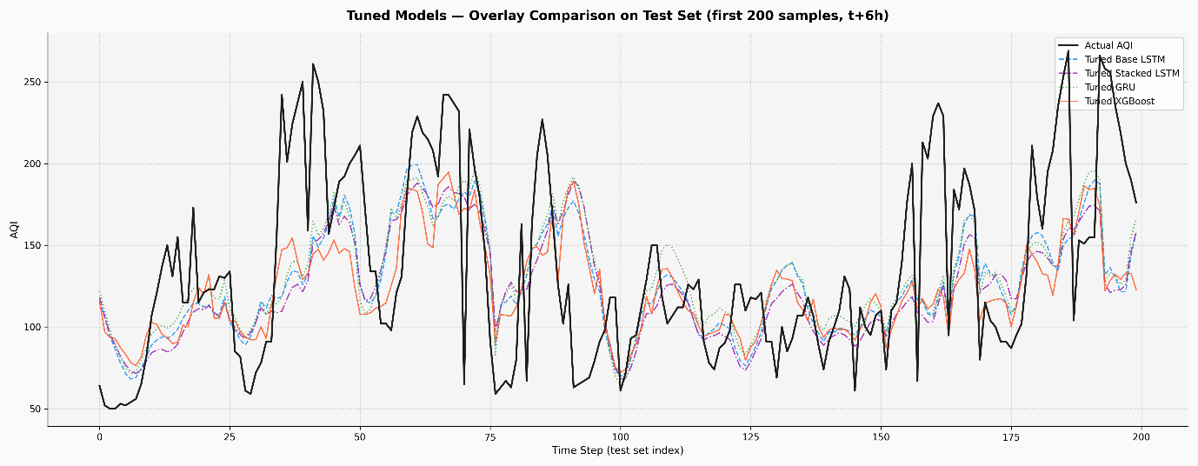
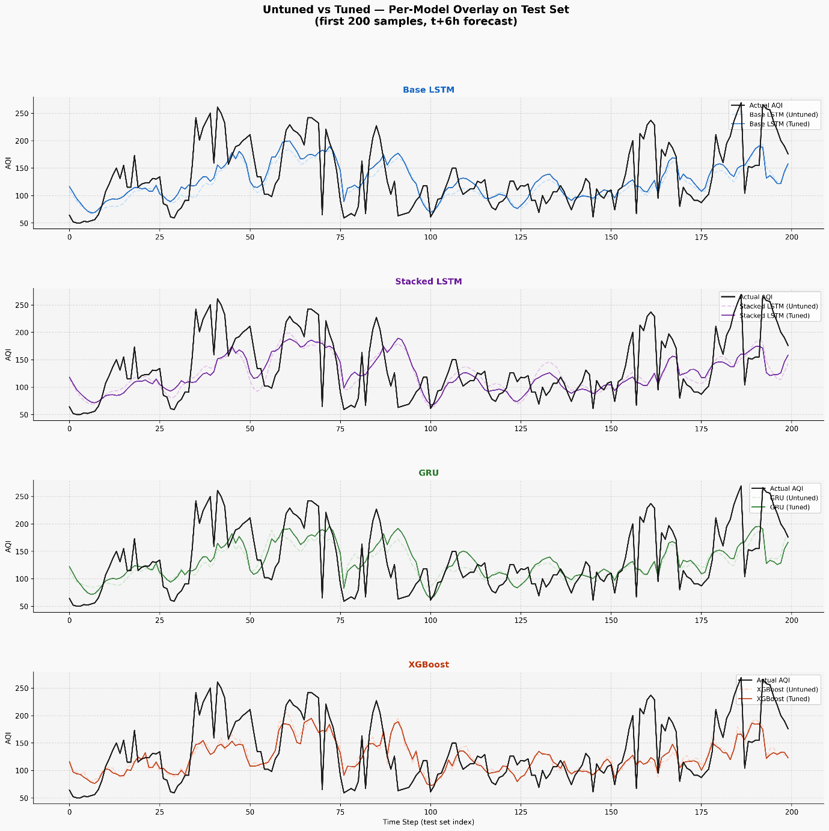
- Common Traits Across All RNN Models (LSTM, Stacked LSTM, GRU)
- Smooth, narrow-amplitude predictions ("regression to the mean") even after tuning, predicted amplitude stays roughly within ~85–195, while actual AQI ranges from 50–270.
- Severe underestimation at high AQI peaks (>200) present in all 6 RNN charts (tuned and untuned); no RNN variant resolves this "prediction ceiling," even with HPO.
- Consistent lag in tracking peaks/troughs a direct consequence of window-based sequence modeling, most visible in the step ~190-200 overshoot described above.
- Over-smoothing in the noisy mid-section (steps ~100-150) none of the three RNN architectures track rapid short-term fluctuations here as well as XGBoost does.
- Uneven benefit from tuning - HPO mainly improves trough-tracking and trend timing, not peak capture; the root cause (MSE loss biasing toward the mean) is not addressed simply by tuning hyperparameters.
In short: all three RNN architectures share the same core weakness — they learn the overall trend well but fail to capture extreme values (spikes), a structural limitation of how these sequence-based models are trained, rather than a flaw specific to any one architecture or a lack of tuning.
- The Post-Peak Overshoot at Steps ~190–200
A pattern worth calling out specifically: at the very end of the test set (steps ~190–200), all three RNN models (LSTM, Stacked LSTM, GRU tuned and untuned alike) show predictions continuing to climb even as actual AQI has already turned downward.
Actual behavior: AQI peaks at ~270 around step 187, then reverses and falls ~260 → ~220 → ~200 ~175–190 by steps 190–200.
Predicted behavior: instead of tracking this decline, the predicted lines keep rising through this stretch (e.g., climbing from ~140 to ~175 in several charts), lagging noticeably behind the actual reversal.
Why this happens:
- Since forecasts are generated from a 48-hour sliding window, at the point where the model produces predictions for steps ~195–200, its input window still contains the very high AQI values from the spike around steps 185–190. The model "sees" a strong recent upward trend and extrapolates it forward.
- The result: while actual AQI has already turned the corner, the prediction keeps "chasing" the peak that has already passed, since it hasn't yet registered the reversal.
Why this is a systemic issue for sequence-based RNNs, not a one-off:
- LSTM/GRU/Stacked LSTM all learn to forecast based on the most recent pattern in the sliding window, giving them an inherently autocorrelation-like behavior — the current prediction is heavily influenced by the immediately preceding value/trend.
- When there's a sudden reversal (as at the step-187 peak), the model needs several time steps to "catch up" and adjust direction — this is a classic phase lag, a well-known limitation of one-step-ahead, window-based time-series forecasting.
This end-of-series overshoot is one of the clearest visual pieces of evidence for the "phase lag" limitation the report describes more generally and is worth citing explicitly as a concrete example

Comprehensive Evaluation

Source Code

